## Experiment No. : 7

Title: Demonstration of extraction of data from multiple sources and loading into SQL Server Using SQL Server Integration Services

Objectives: 1. To apply data conversion transformation

2. To apply Union All transformation to demonstrate extraction of data from multiple sources and loading into SQL Server

Key concepts: Union All, Multisource data extraction, data conversion

Steps to extract data from different types of sources into SQL Server

The Union All transformation is used to combine all the inputs into one output and the columns in the inputs must be mapped to columns in the output. Ideally all the inputs have the same number of columns with the same data type. If not you will have to make sure at least one column in the inputs mapping to the column in the output and there is no conflict among the data types of the mapping columns.

The below demonstrated example uses the Excel file as a data source and add a new data source from a flat file. Then we'll use the Union All transformation to combine the 2 inputs into one output. Let's check the Flat file first.

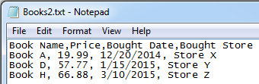

The file Books2.txt was saved in C:\SSIS folder and we added additional column "Bought Store" for testing purpose. Take the following steps to test the transform.

1. Create SSIS type project and drag and drop dataflow task and double click dataflow
2. Drag and drop a [Flat File Connection Manager](http://www.excoded.com/learn/ssis/ssis_flatfileconnectionmanager.php) to point to the flat file we displayed above.

The default data types of all the columns are string type.

1. Change the data type of the Price column to DT_R8 and the type of Bought Date to DT_DATE in the Advanced tab in Flat File Connection Manager Editor.

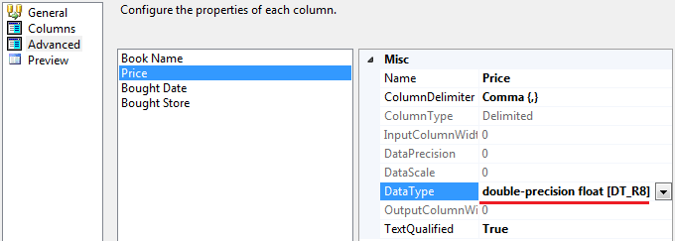

1. Click OK button to close the editor and then click Data Flow tab to go to data flow edit area.
2. Right-click the Flat File Source and choose "Edit..." to open the editor and select the Flat File Connection Manager as its connection manager. Click Columns tab, the columns looks like below.

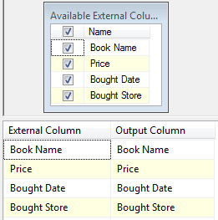

1. Similarly drag and drop Excel source and mention excel filename. Drag and drop Data Conversion and Connect the output of excel source to input to data conversion. Drag and drop union all transformation. Connect the output from the "Data Conversion" transform and Flat File Source as input to Union All.

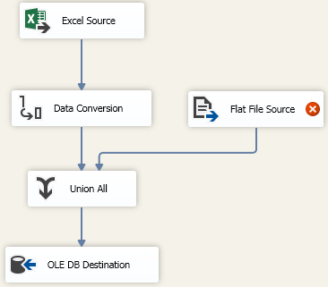

1. Click OK button. Then right-click Union All transform and choose "Edit" to open the editor. Then change the setting in Union All Input 2 as shown below.

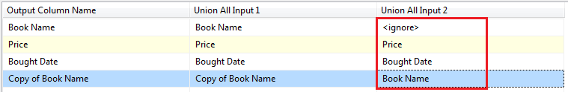

There is no column in Input 2 to map to the output column "Book Name" because it was converted to Copy of Book Name with string type. You can add a "store" column at the end of the mapping list if you want.

1. Click OK button and Right-click OLE DB Destination to open its editor and click Mappings tab to make sure the mappings of columns are correctly.

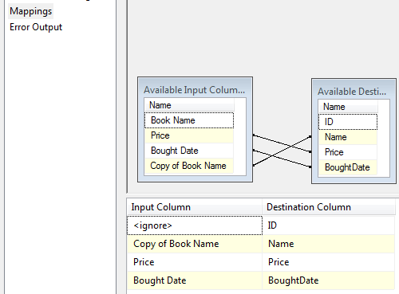

1. Click OK and add data viewer between Union All and OLE DB Destination and then run the package.

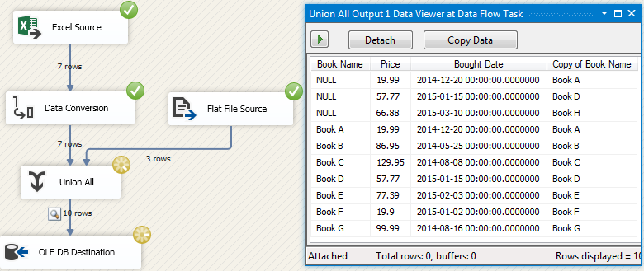

The first 3 records in the data viewer are the data from the flat file and the others are from the Excel file. No record was removed even if the record had the same data as the others.

Bottom of Form